LAB EXPERIMENTS

1. Write an assembly language program for adding two 8-bit data A7 A6 A5 A4 A3 A2
A1 A0 and B7 B6 B5 B4 B3 B2 B1 B0 using 8085 processor.
8 BIT ADDITION
LDA 2050
MOV B,A
LDA 2052
ADD B
STA 2054
HLT
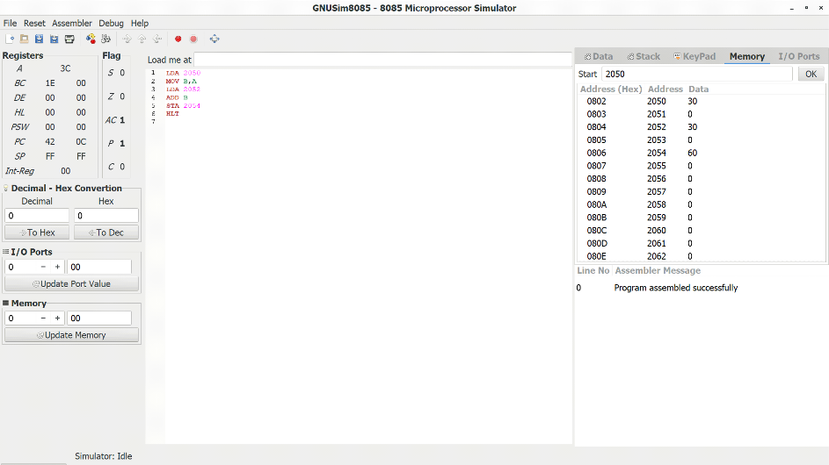

2. Write an assembly language program for subtraction of two 8-bit data A7 A6 A5 A4
A3 A2 A1 A0 and B7 B6 B5 B4 B3 B2 B1 B0 using 8085 processor.
8 BIT SUBTRACTION
LDA 2050
MOV B,A
LDA 2052
SUB B
STA 2054
HLT
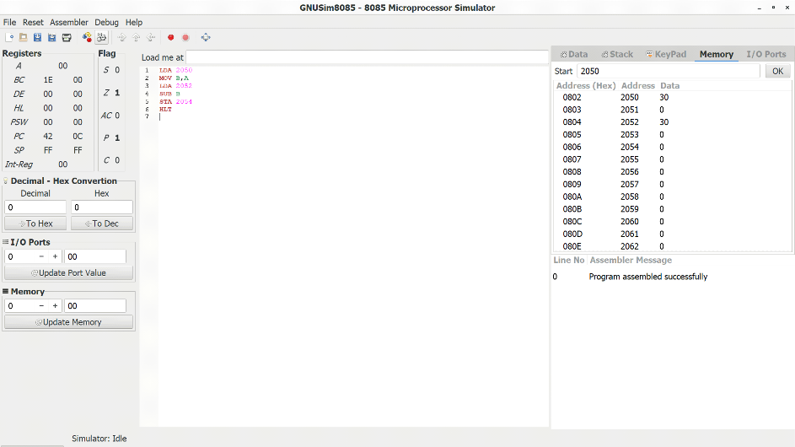

3. Write an assembly language program for adding two 16-bit data using 8086
processor.
16 BIT ADDITION
LHLD 2500
XCHG
LHLD 2502
MOV A,E
ADD L
MOV L,A
MOV A,D
ADC H
MOV H,A
SHLD 2504
HLT
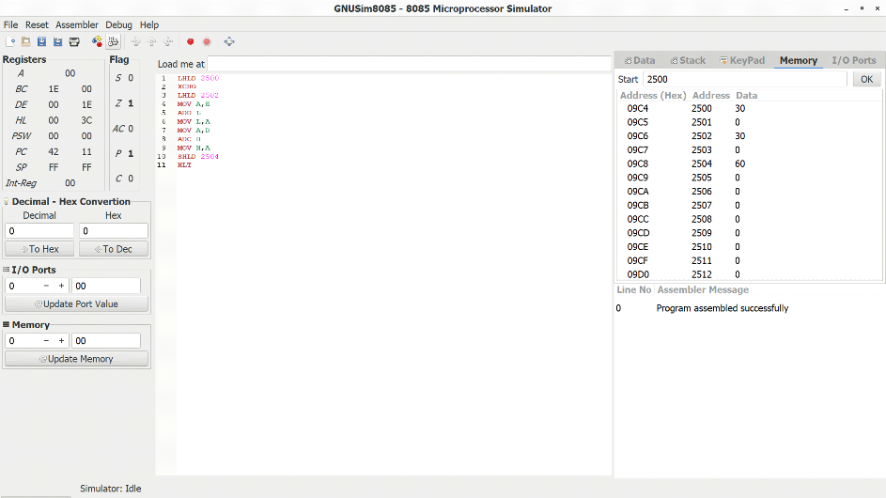

4. Write an assembly language program for subtracting two 16-bit data using 8086
processor.
16 BIT SUBTRACTION
LHLD 2500
XCHG
LHLD 2502
MOV A,E
SUB L
MOV L,A
MOV A,D
ADC H
MOV H,A
SHLD 2504 ,HLT
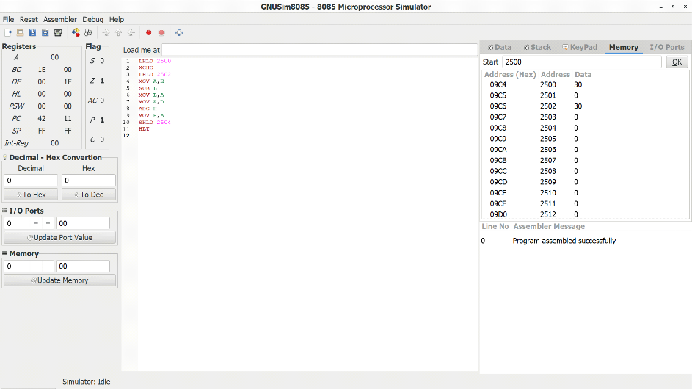

5. Write an assembly language program for multiplication of two 8-bit data A7 A6 A5
A4 A3 A2 A1 A0 and B7 B6 B5 B4 B3 B2 B1 B0 using 8085 processor.
8 BIT MULTIPLICATION
MVI D,00
MVI A,00
LXI H,4150
MOV B.,M
INX H
MOV C,M
LOOP: ADD B
JNC NEXT
INR D
NEXT: DCR C
JNZ LOOP
STA 4152
MOV A,D
STA 4153
HLT
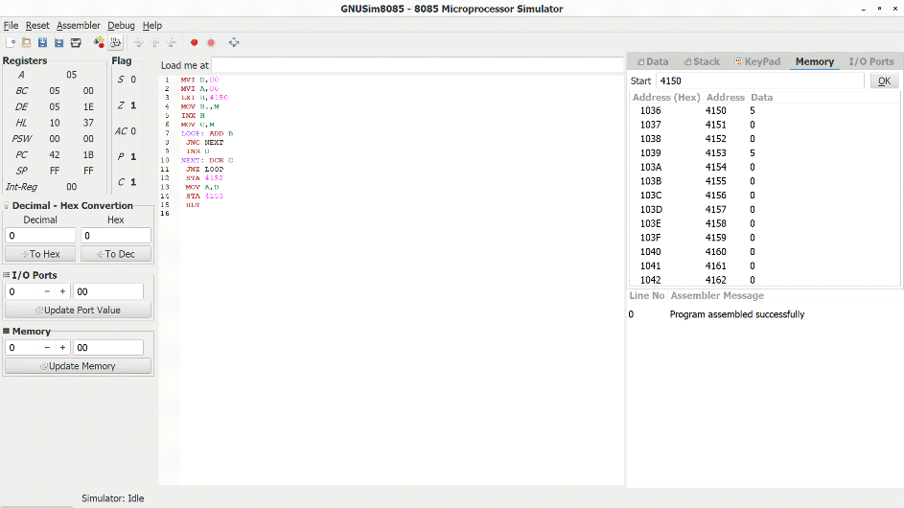

6. Write an assembly language program for division of two 8-bit data A7 A6 A5 A4 A3
A2 A1 A0 and B7 B6 B5 B4 B3 B2 B1 B0 using 8085 processor.

8 BIT DIVISION
LXI H,1100
MOV B,M
MVI C,00
INX H
MOV A,M
LOOP: CMP B
JC SKIP
SUB B
INR C
JMP LOOP
SKIP: STA 1102
MOV A,C
STA 1103
HLT

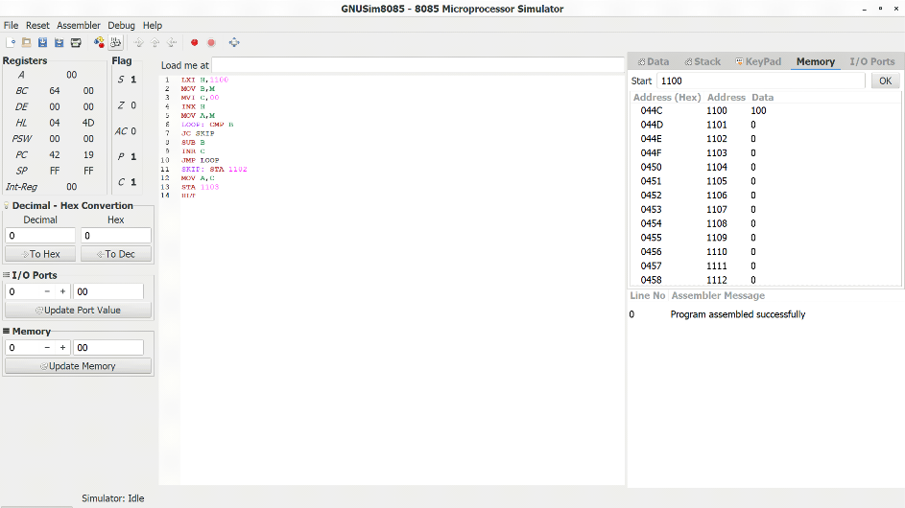

7. Write an assembly language program for multiplying two 16-bit data using 8086
processor.
16 BIT MULTIPLICATION
LHLD 8500
MOV D,H
MOV E,L
LDA 8502
MOV C,A
CPI 00
JZ LOOP1
LXI H,0000
LOOP: DAD D
DCR C
JZ LOOP1
JMP LOOP
LOOP1: SHLD 8505
HLT
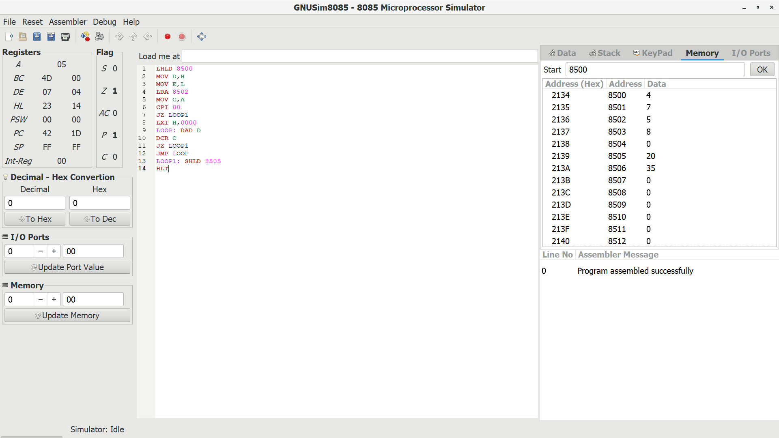
8. Write an assembly language program for dividing two 16-bit data using 8086
processor.
LXI B,0000H
LHLD 8002
XCHG
LHLD 8000
LOOP: MOV A,L
SUB E
MOV L,A
MOV A,H
SBB D
MOV H,A
JC SKIP
INX B
JMP LOOP
SKIP: DAD D
SHLD 8006
MOV L,C
MOV H,B
SHLD 8004
HLT
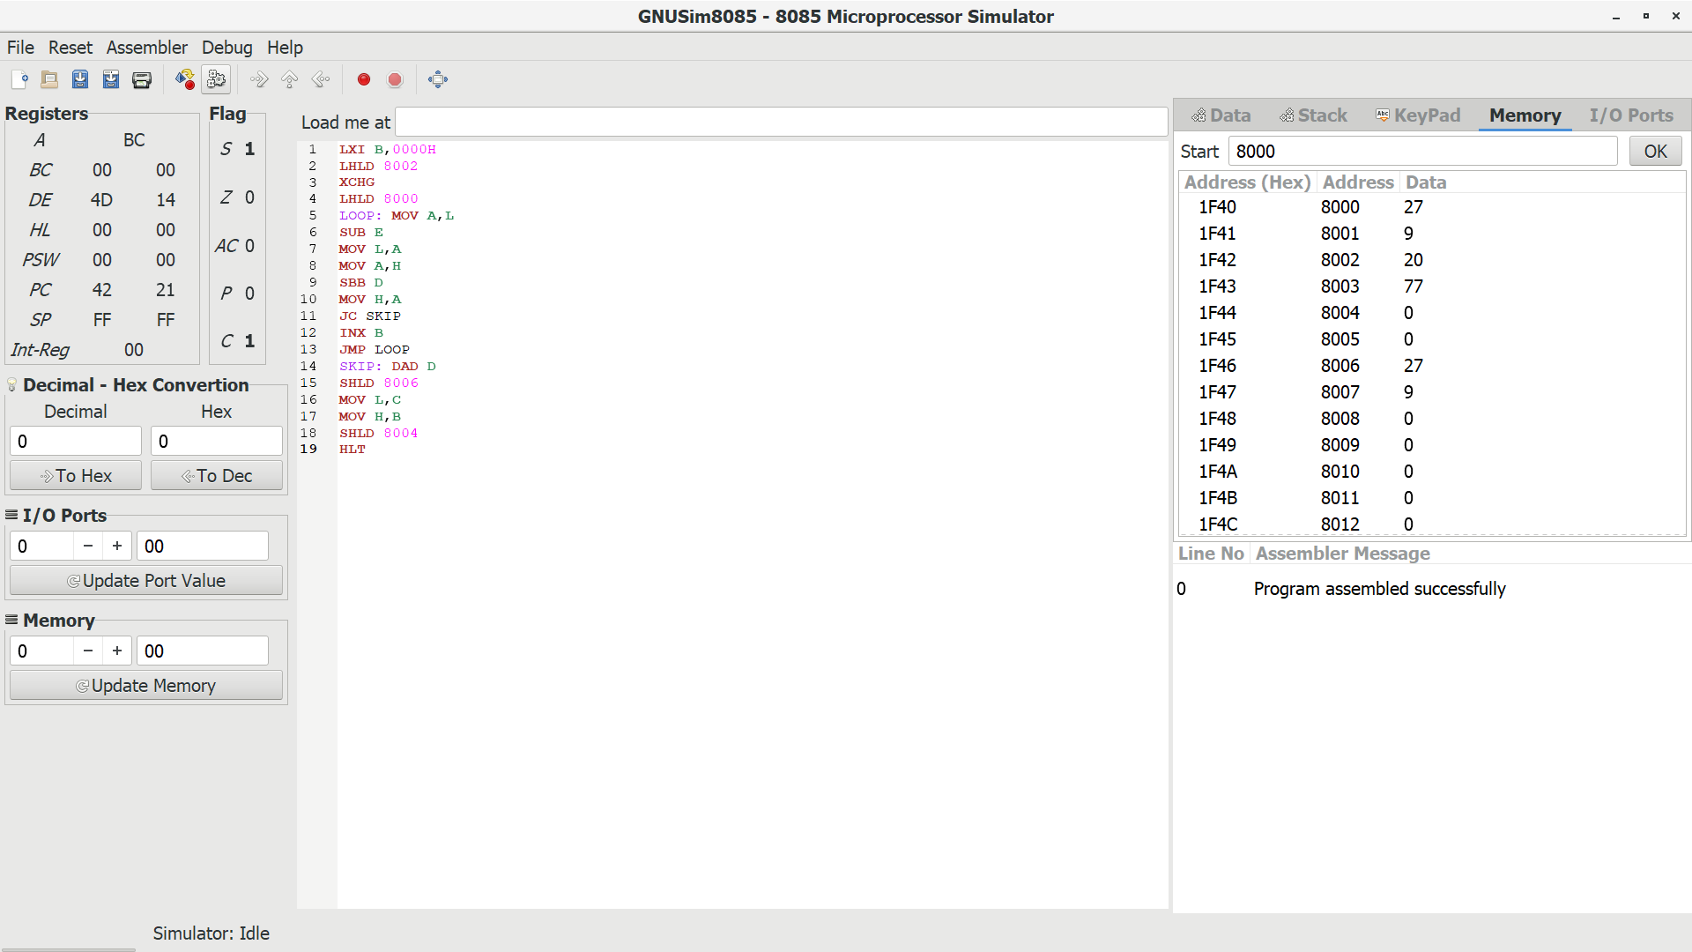
9. Design and implement 2-bit half adder using logisim simulator.
AIM:
To design and implement the two bit half adder using Logisim simulator.
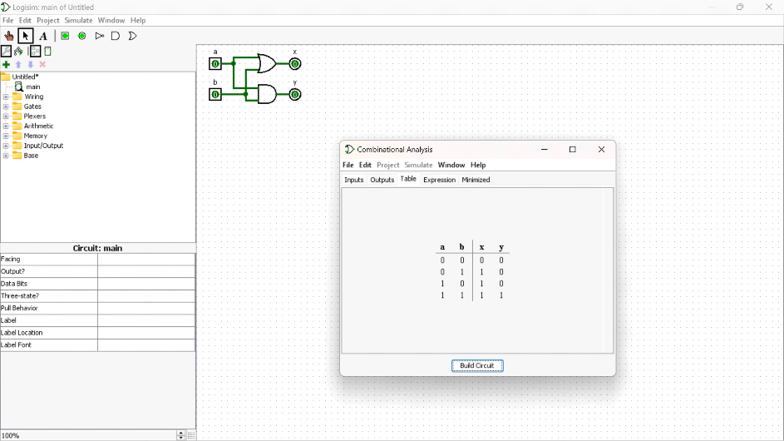

RESULT:-Hence the designing of the 2-bit half adder using logisim simulator has been
implemented successfully
10. Design and implement 3-bit full adder using logisim simulator.
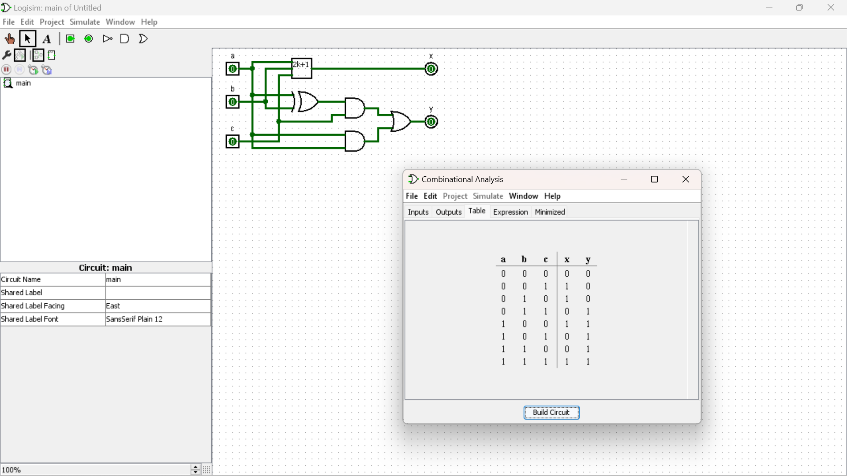
11. Design and implement 2-bit half adder with NAND using logisim simulator.
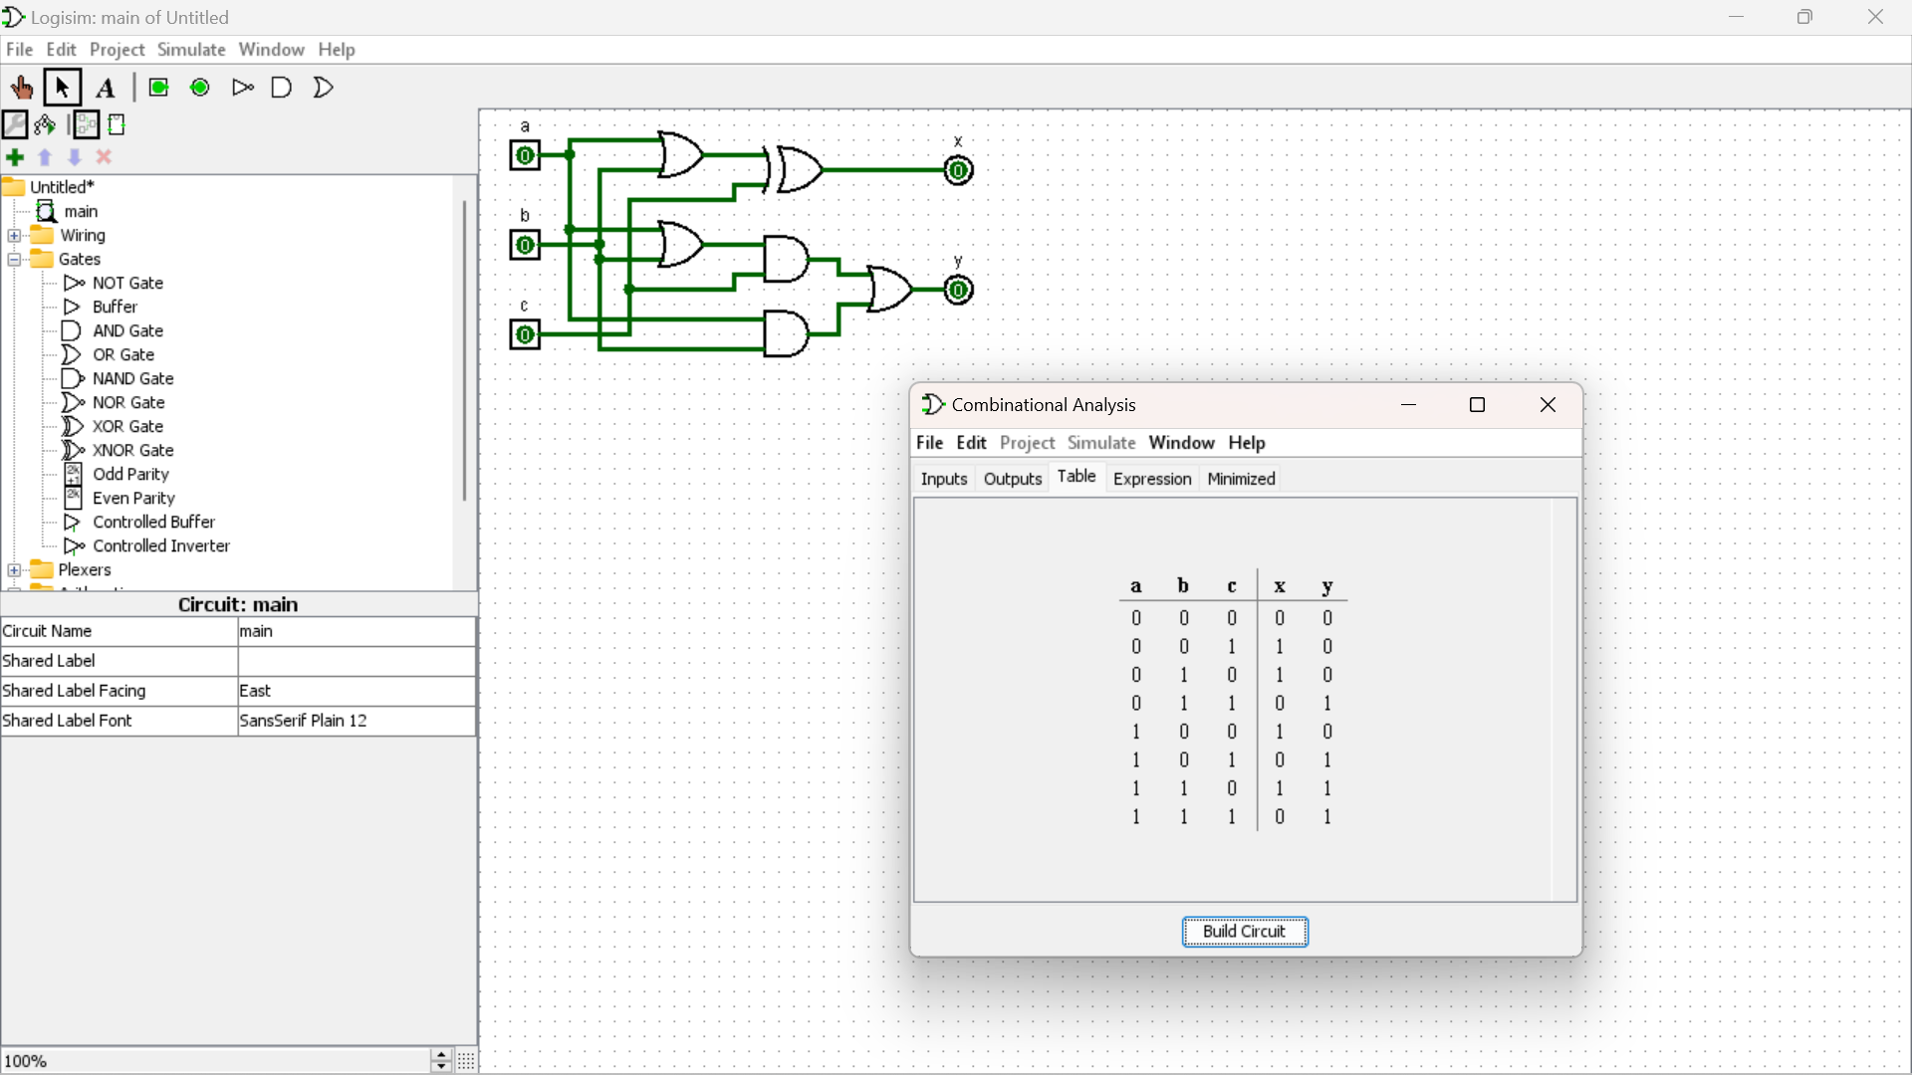
12. Write an assembly language program to find factorial of n in the given number.
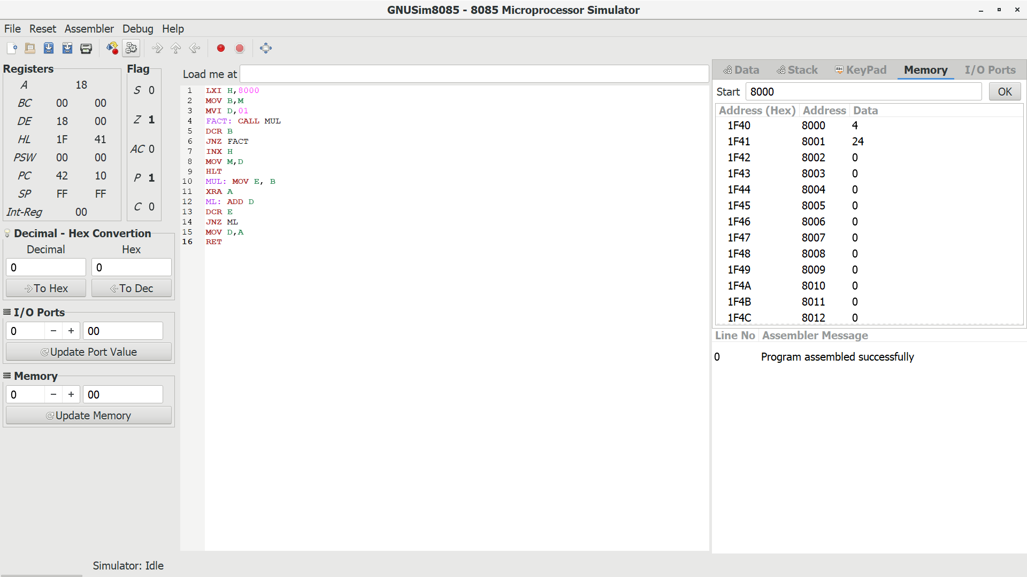

13. Write an assembly language program to find the largest number in an array.
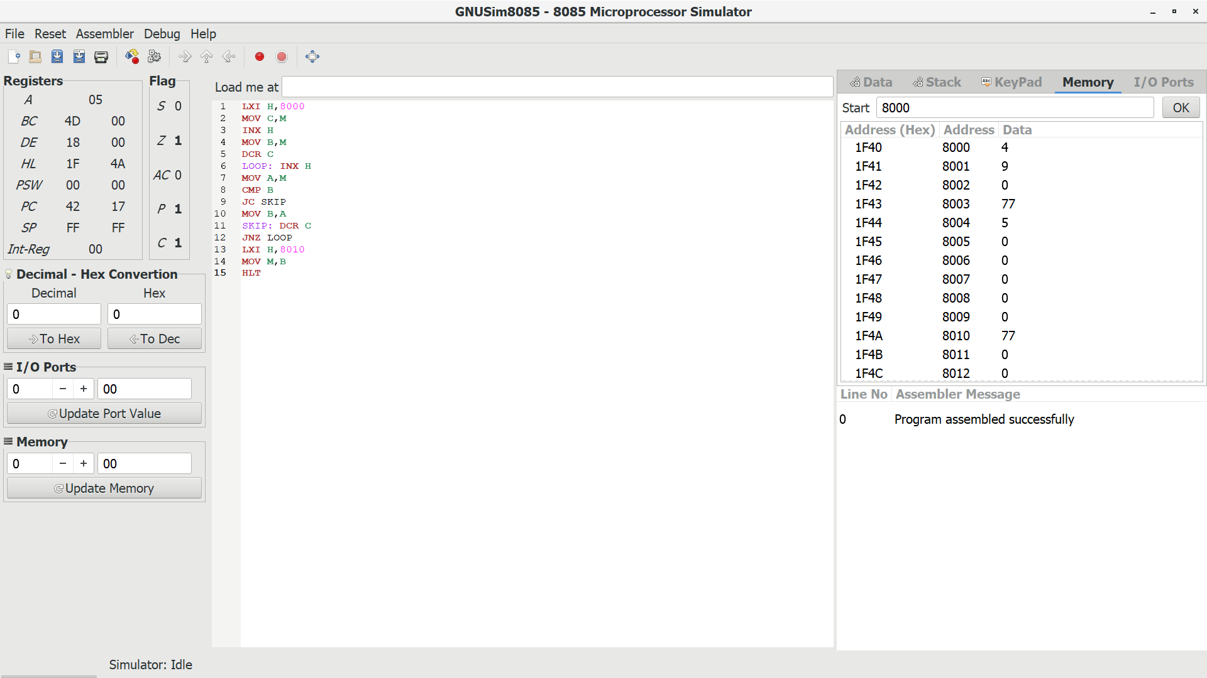
14. Design of 2 stage pipeline for addition and subtraction of two numbers using any
high level language.
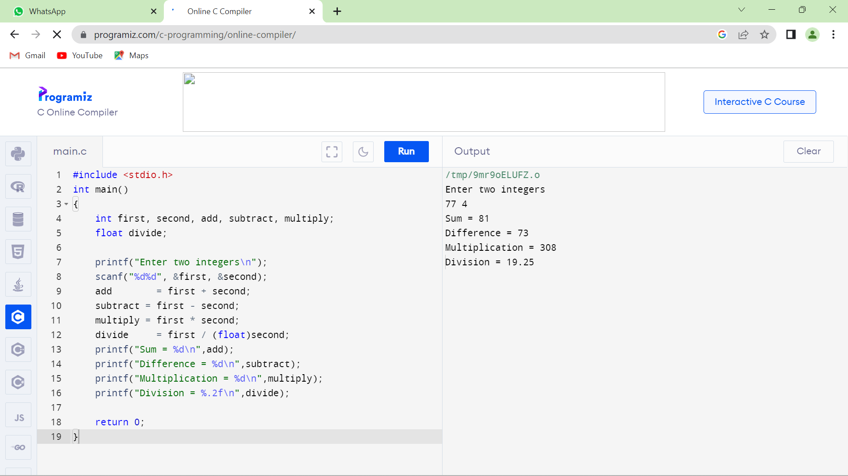
15. Design of 3 stage pipeline for AND, OR, NAND of two numbers using any high level language.
